**Award Criteria;** The Award Criteria to assess effectively all suppliers that are able to demonstrated added value for money within a competitive marketplace are listed below;

**1.3a** Whole Life Cost (WLC) Formula explained; For further explanation on the requirements for WLC please see explanation figure below;

|  |  |
| --- | --- |
| **Headline Award Criteria** | **Weighting** |
| Whole Life Cycle Cost Analysis | **30%** |
| Quality (broken into a sub criteria below) | **70%** |
| * Compliance to the Specification | (30%) |
| * Sustainability & Environmental | (15%) |
| * Delivery | (5%) |
| * Warranty | (10%) |
| * After Sales and Technical back up | (10%) |

|  |  |
| --- | --- |
| **TOTAL %** | **100%** |

**Calculate for life of Instrument e.g. 10 years**

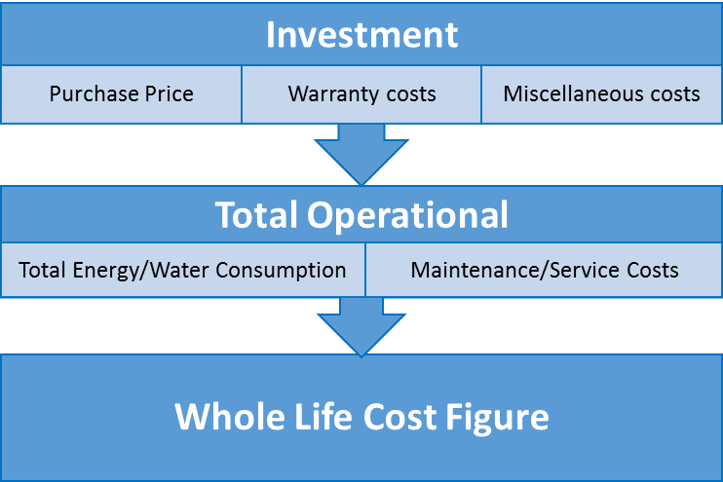

**+**

**=**

***Figure 2: 2 Step Life Cycle analysis matrix for Lab Equipment***

|  |  |
| --- | --- |
| **8.6 SUSTAINABILITY AND ENVIRONMENTAL** | **Question Weighting Criteria Reference** |
| **8.6.1**: Will your company remove all packaging from the University Campus (includes all remote sites affiliated with campus) once the product has been commissioned? Please provide evidence of how you ensure that disposal of packaging is as environmentally friendly as possible e.g. re-using or recycling. | CR |
| **8.6.2:** Does your company make efforts to reduce the total volume of packaging needed for the delivery, if so how? | CR |
| **8.6.3:** Would your company be willing to consider more sustainable alternatives to packaging materials? Can you confirm if you will implement these into this tender, if awarded? | CR |
| **8.6.4:** Will your company ensure that either you or any third party couriers, consolidate all items requiring delivery into one load to reduce the number of journeys to and from campus? | CR |
| **8.6.5:** Can you, as supplier of this equipment, accept responsibility for the sustainable disposal (through a WEEE licensed facility) or re-use of this equipment once it’s reached the end of its usable life cycle? | CR |